# Practical 8 Create an HTML page with Inline Style sheet.

<html>

<head>

<title>Inline Style Sheet</title>

</head>

<body>

<h1 style="text-align:center; border:orange dashed 2px ; padding:2cm 3cm 4cm 5cm">Web Technology.</h1>

<p style="border:blue medium solid ; padding-top:2cm; padding-left:3cm; font-family:Tahoma">Kaustubh Wade(160410116050)</p>

<p style="border:green thick dotted ; padding-bottom:2cm; padding-right:3cm">Web Technology.</p>

</body>

</html>

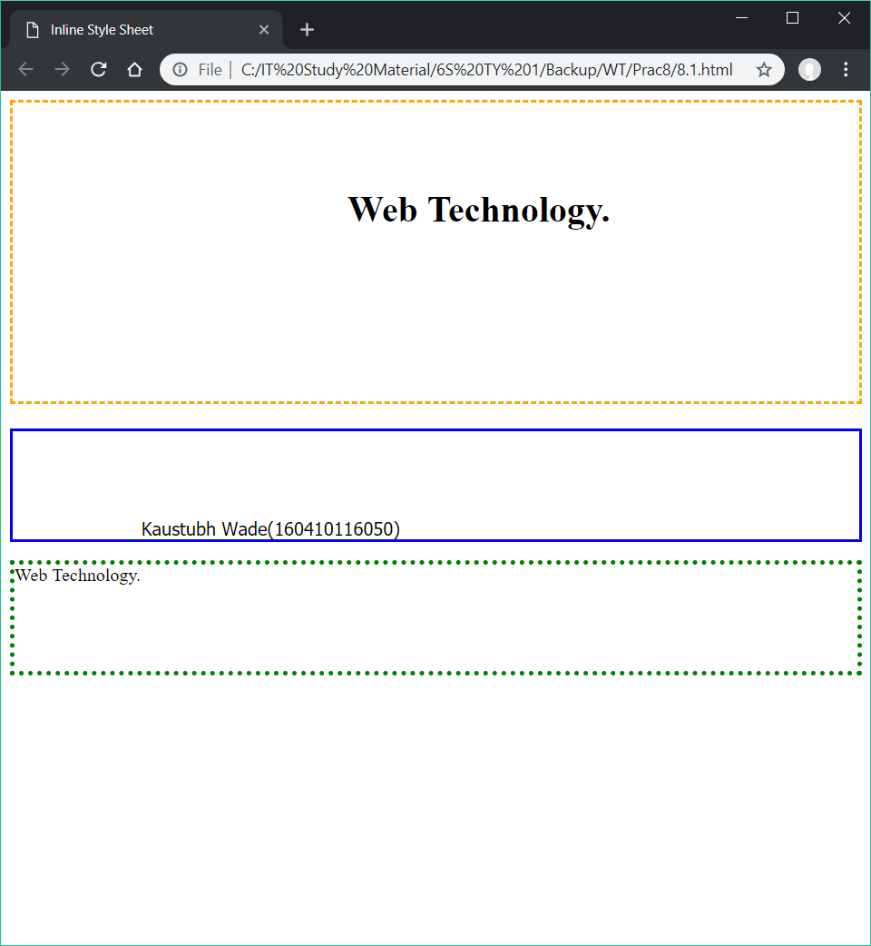

<html>

<head>

<title>P8</title>

</head>

<body>

<h1 style="border:orange thin double ; margin:2cm 3cm 4cm 5cm";>Web Technology.</h1>

<p style="border:blue medium dashed ; margin-top:2cm; margin-left:3cm;font-size:150%">Kaustubh Wade(160410116050)</p>

<p style="border:green thick dotted ; margin-bottom:2cm; margin-right:3cm; font-size:150%">Web Technology</p>

</body>

</html>

